JFrog OSS Package Management Solution
Version 1.0 – Delivered by JFrog Solution Engineering
Document Type: Full Governance & Architecture Specification
Audience: Dev Team, Configuration Manager Team, Security Team

1. Overview
This document provides a complete OSS (Open Source Software) package governance solution using JFrog Artifactory and JFrog Xray, based on the customer’s original architecture and workflow diagram.
The goal of this solution is to:
• Ensure strong production security enforcement
• Protect developer productivity
• Provide a consistent flow for acquiring and approving OSS packages
• Support CI/CD integration
• Enable controlled exception handling (temporary ignore rules)
• Align with enterprise software supply chain governance best practices

2. Roles & Responsibilities
2.1 Development Team
• Builds Java/Maven applications
• Retrieves dependencies from maven-dev-virtual
• Commits code and triggers CI
• Requests temporary ignore rules when needed
2.2 Configuration Manager Team
• Manages repository structure and lifecycle
• Controls virtual/local/remote repositories
• Ensures DEV and PROD repositories remain fully separated
• Oversees package flow into CI
2.3 Security Team
• Maintains Xray Dev Policy and Prod Policy
• Reviews and approves violation exceptions
• Creates temporary ignore rules
• Performs compliance and audit reviews

3. Repository Architecture
The solution uses separate DEV and PROD repository structures to prevent PROD security policies from blocking development.
3.1 DEV Repository Structure (Used by Developers)
Virtual Repository:
maven-dev-virtual
Includes:
maven-dev-local
maven-dev-remote (proxy to Maven Central)
Policy Behavior:
• Block: Critical
• Allow: High / Medium / Low
Purpose:
Enable fast development while giving developers visibility into vulnerabilities without blocking productivity.
3.2 PROD Repository Structure (Used by CI Builds)
Virtual Repository:
maven-prod-virtual
Includes:
maven-prod-local
maven-prod-remote (controlled remote repository)
Policy Behavior:
• Block: Critical / High
• Optional: block newly published packages via curation (<14 days old)
Purpose:
Protect production pipelines by preventing risky packages from being approved or deployed.

4. End-to-End Process Workflow
Below is the complete Maven dependency governance flow, based on the user-provided diagram.
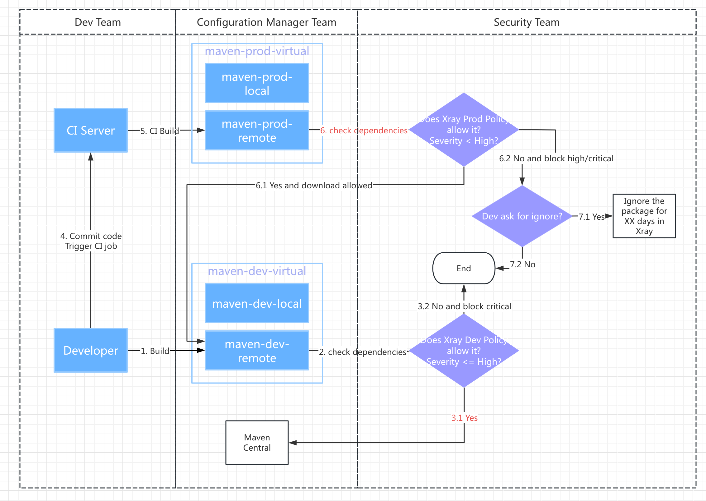
4.1 Developer Build Process
1 Developer builds locally using maven-dev-virtual
2 Xray Dev Policy evaluates dependencies
3 If Critical → block
4 If High → allow
4.2 Code Commit Triggers CI
5 CI pulls dependencies from maven-prod-virtual
4.3 Xray PROD Policy Check
6 Xray evaluates: Severity < High ?
If Yes:
• Download allowed
• Build continues
If No:
• Block High/Critical vulnerabilities
• If the developer requests to use the vulnerable package as an exception, the developer needs to send the violations in Xray to the Security Team to review
4.4 Exception Workflow
7 Developer asks Security for exception
8 Security Team evaluates and decides:
If approved → Temporary Ignore Rule
• Specific CVE
• Specific package
• Specific version
• Specific repository (Prod only)
• Includes expiration window (in XXX days)
If not approved
• Build fails
• Dependency cannot be used in PROD pipeline

5. Detailed Flowcharts
5.1 Architecture Flowchart

6. Xray Policy Recommendations
6.1 DEV Policy
Severity
Action
Critical Block
High Allow
Medium Allow
Low Allow
Purpose: developer productivity + visibility.
6.2 PROD Policy
Severity
Action
Critical Block
High Block
Medium Allow
Low Allow

Optional Enhancements:
• Block packages published in last X days in Curation
• Require SBOM availability
• Require provenance / signature info

7. Exception Handling Workflow (Ignore Rules)
7.1 When to Request an Ignore
A developer may request an exception when:
• No fixed version is available
• Business impact requires temporary usage
• Team agrees to accept temporary risk
7.2 Ignore Rule Configuration
Each ignore rule must specify:
• Package name
• Version
• CVE ID
• Target repository (Prod only)
• Expiration date (XXX days)

8. Best Practices
8.1 Strongly Separate DEV & PROD Remotes
Avoid dependency contamination from DEV into PROD.
8.2 Use Promotion-Based Lifecycle
DEV → TEST → STAGE → PROD
Each stage is scanned and approved.
8.3 Focus on Precision Scanning
• Scan builds (not just repos)
• Require SBOM
• Enforce license policies

9. Optional Enhancements (Recommended)
9.1 Enable JFrog Curation (SaaS)
Features:
• Real-time risk filtering
• Zero-day vulnerability blocking
• Allow/deny lists
• Enable contextual analysis to reduce the false-positives.(JAS)

9.2 SBOM Integration
Use:
• CycloneDX
• SPDX
9.3 Advanced DevSecOps Integrations
• IDE scanning
• CI pipeline quality gates
• Git commit scanning using frogbot

End of Document
Prepared by JFrog Solution Engineering Team

